

BAŞKENT ÜNİVERSİTESİ
ELEKTRİK-ELEKTRONİK MÜHENDİSLİĞİ BÖLÜMÜ

EEM 312 ~ SAYISAL ELEKTRONİK

LABORATUVAR UYGULAMASI

RAPOR

Deney Adı : CMOS Tersleyici Karakteristiği
Deney Numarası : Y3
Deney Tarihi : 29.03.2006

Öğrencinin Adı : Oğuz BOZKURT
Öğrencinin Numarası : 20393948

1)
a)
SORU1a
.MODEL MOSN NMOS LEVEL=2 LD=0.15U TOX=200.0E-10
+ NSUB=5.36726E+15 VTO=0.743469 KP=8.00059E-05 GAMMA=0.543
+ PHI=0.6 U0=655.881 UEXP=0.157282 UCRIT=31443.8
+ DELTA=2.39824 VMAX=55260.9 XJ=0.25U LAMBDA=0.0367072
+ NFS=1E+12 NEFF=1.001 NSS=1E+11 TPG=1.0 RSH=70.00
+ CGDO=4.3E-10 CGSO=4.3E-10 CJ=0.0003 MJ=0.6585
+ CJSW=8.0E-10 MJSW=0.2402 PB=0.58
.MODEL MOSP PMOS LEVEL=2 LD=0.15U TOX=200.0E-10
+ NSUB=4.3318E+15 VTO=-0.738861 KP=2.70E-05 GAMMA=0.58
+ PHI=0.6 U0=261.977 UEXP=0.323932 UCRIT=65719.8
+ DELTA=1.79192 VMAX=25694 XJ=0.25U LAMBDA=0.0612279
+ NFS=1E+12 NEFF=1.001 NSS=1E+11 TPG=-1.0 RSH=120.6
+ CGDO=4.3E-10 CGSO=4.3E-10 CJ=0.0005 MJ=0.5052
+ CJSW=1.349E-10 MJSW=0.2417 PB=0.64

M1 2 1 0 0 MOSN W=1.8u L=1.2u NRS=0.333 NRD=0.333
+ AD=6.5p PD=9.0u AS=6.5p PS=9.0u

VDD 3 0 DC 3.1
VIN 1 0 PULSE(0 3 0 1ns 1ns 5ns 10ns)
R1 3 2 100K
C1 2 0 1F
.CONTROL
DC VIN 0 3.1 0.1
PLOT V(2) VS V(1)
.ENDC

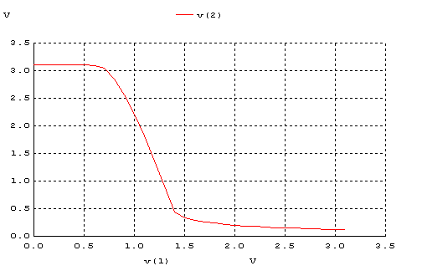

b)
SORU1b
.MODEL MOSN NMOS LEVEL=2 LD=0.15U TOX=200.0E-10
+ NSUB=5.36726E+15 VTO=0.743469 KP=8.00059E-05 GAMMA=0.543
+ PHI=0.6 U0=655.881 UEXP=0.157282 UCRIT=31443.8
+ DELTA=2.39824 VMAX=55260.9 XJ=0.25U LAMBDA=0.0367072
+ NFS=1E+12 NEFF=1.001 NSS=1E+11 TPG=1.0 RSH=70.00
+ CGDO=4.3E-10 CGSO=4.3E-10 CJ=0.0003 MJ=0.6585
+ CJSW=8.0E-10 MJSW=0.2402 PB=0.58
.MODEL MOSP PMOS LEVEL=2 LD=0.15U TOX=200.0E-10
+ NSUB=4.3318E+15 VTO=-0.738861 KP=2.70E-05 GAMMA=0.58
+ PHI=0.6 U0=261.977 UEXP=0.323932 UCRIT=65719.8
+ DELTA=1.79192 VMAX=25694 XJ=0.25U LAMBDA=0.0612279
+ NFS=1E+12 NEFF=1.001 NSS=1E+11 TPG=-1.0 RSH=120.6
+ CGDO=4.3E-10 CGSO=4.3E-10 CJ=0.0005 MJ=0.5052
+ CJSW=1.349E-10 MJSW=0.2417 PB=0.64

M1 2 0 3 3 MOSP W=1.8u L=1.2u NRS=0.333 NRD=0.333
+ AD=6.5p PD=9.0u AS=6.5p PS=9.0u
M2 2 1 0 0 MOSN W=1.8u L=1.2u NRS=0.333 NRD=0.333
+ AD=6.5p PD=9.0u AS=6.5p PS=9.0u

VDD 3 0 DC 3.1
VIN 1 0 PULSE(0 3.1 0 1ns 1ns 5ns 10ns)
C1 2 0 1F
.CONTROL
DC VIN 0 3.1 0.01
PLOT V(2) VS V(1)
.ENDC

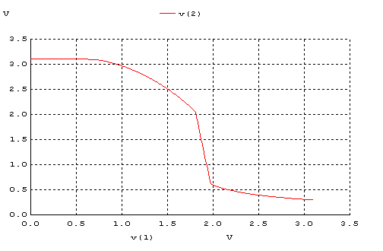

c)

SORU1c
.MODEL MOSN NMOS LEVEL=2 LD=0.15U TOX=200.0E-10
+ NSUB=5.36726E+15 VTO=0.743469 KP=8.00059E-05 GAMMA=0.543
+ PHI=0.6 U0=655.881 UEXP=0.157282 UCRIT=31443.8
+ DELTA=2.39824 VMAX=55260.9 XJ=0.25U LAMBDA=0.0367072
+ NFS=1E+12 NEFF=1.001 NSS=1E+11 TPG=1.0 RSH=70.00
+ CGDO=4.3E-10 CGSO=4.3E-10 CJ=0.0003 MJ=0.6585
+ CJSW=8.0E-10 MJSW=0.2402 PB=0.58
.MODEL MOSP PMOS LEVEL=2 LD=0.15U TOX=200.0E-10
+ NSUB=4.3318E+15 VTO=-0.738861 KP=2.70E-05 GAMMA=0.58
+ PHI=0.6 U0=261.977 UEXP=0.323932 UCRIT=65719.8
+ DELTA=1.79192 VMAX=25694 XJ=0.25U LAMBDA=0.0612279
+ NFS=1E+12 NEFF=1.001 NSS=1E+11 TPG=-1.0 RSH=120.6
+ CGDO=4.3E-10 CGSO=4.3E-10 CJ=0.0005 MJ=0.5052
+ CJSW=1.349E-10 MJSW=0.2417 PB=0.64

M1 2 1 3 3 MOSP W=1.8u L=1.2u NRS=0.333 NRD=0.333
+ AD=6.5p PD=9.0u AS=6.5p PS=9.0u

VDD 3 0 DC 3.1
VIN 1 0 PULSE(0 3.1 0 1ns 1ns 5ns 10ns)
R1 2 0 100K
C1 2 0 1F
.CONTROL
DC VIN 0 3.1 0.1
PLOT V(2) VS V(1)
.ENDC

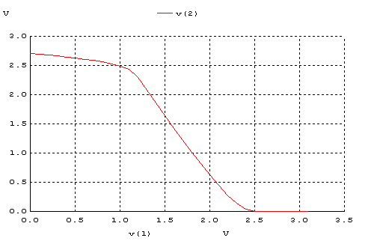

d)

SORU1d
.MODEL MOSN NMOS LEVEL=2 LD=0.15U TOX=200.0E-10
+ NSUB=5.36726E+15 VTO=0.743469 KP=8.00059E-05 GAMMA=0.543
+ PHI=0.6 U0=655.881 UEXP=0.157282 UCRIT=31443.8
+ DELTA=2.39824 VMAX=55260.9 XJ=0.25U LAMBDA=0.0367072
+ NFS=1E+12 NEFF=1.001 NSS=1E+11 TPG=1.0 RSH=70.00
+ CGDO=4.3E-10 CGSO=4.3E-10 CJ=0.0003 MJ=0.6585
+ CJSW=8.0E-10 MJSW=0.2402 PB=0.58
.MODEL MOSP PMOS LEVEL=2 LD=0.15U TOX=200.0E-10
+ NSUB=4.3318E+15 VTO=-0.738861 KP=2.70E-05 GAMMA=0.58
+ PHI=0.6 U0=261.977 UEXP=0.323932 UCRIT=65719.8
+ DELTA=1.79192 VMAX=25694 XJ=0.25U LAMBDA=0.0612279
+ NFS=1E+12 NEFF=1.001 NSS=1E+11 TPG=-1.0 RSH=120.6
+ CGDO=4.3E-10 CGSO=4.3E-10 CJ=0.0005 MJ=0.5052
+ CJSW=1.349E-10 MJSW=0.2417 PB=0.64

M1 2 1 3 3 MOSP W=1.8u L=1.2u NRS=0.333 NRD=0.333
+ AD=6.5p PD=9.0u AS=6.5p PS=9.0u
M2 2 1 0 0 MOSN W=1.8u L=1.2u NRS=0.333 NRD=0.333
+ AD=6.5p PD=9.0u AS=6.5p PS=9.0u

VDD 3 0 DC 3.1
VIN 1 0 PULSE(0 5 0 1ns 1ns 5ns 10ns)
C1 2 0 1F
.CONTROL
DC VIN 0 5 0.1
PLOT V(2) VS V(1)
.ENDC

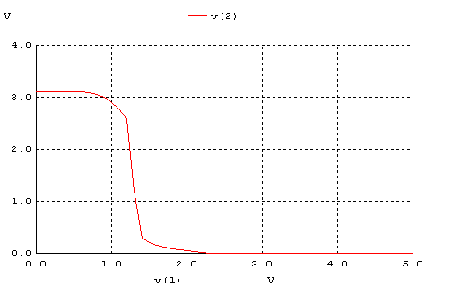

Tablo 1 - DC analiz sonuçları
 | V_{OH} | V_{OL} | V_{IH} | V_{IL} | V_{M} | NM_{H} | NM_{L}
(a) | 3,1V | 120mV | 1,48V | 0,7V | 1,23V | 1.62V | 580mV
(b) | 3,1V | 300mV | 1.98V | 1,3V | 1,63V | 1.12V | 1.0V
(c) | 2,7V | 0V | 2,3V | 1,1V | 1,54V | 0.4V | 1,1V
(d) | 3,1V | 0V | 1,4V | 1,2V | 1,30V | 1.7V | 1,2V

2)
a)
SORU2a
.MODEL MOSN NMOS LEVEL=2 LD=0.15U TOX=200.0E-10
+ NSUB=5.36726E+15 VTO=0.743469 KP=8.00059E-05 GAMMA=0.543
+ PHI=0.6 U0=655.881 UEXP=0.157282 UCRIT=31443.8
+ DELTA=2.39824 VMAX=55260.9 XJ=0.25U LAMBDA=0.0367072
+ NFS=1E+12 NEFF=1.001 NSS=1E+11 TPG=1.0 RSH=70.00
+ CGDO=4.3E-10 CGSO=4.3E-10 CJ=0.0003 MJ=0.6585
+ CJSW=8.0E-10 MJSW=0.2402 PB=0.58
.MODEL MOSP PMOS LEVEL=2 LD=0.15U TOX=200.0E-10
+ NSUB=4.3318E+15 VTO=-0.738861 KP=2.70E-05 GAMMA=0.58
+ PHI=0.6 U0=261.977 UEXP=0.323932 UCRIT=65719.8
+ DELTA=1.79192 VMAX=25694 XJ=0.25U LAMBDA=0.0612279
+ NFS=1E+12 NEFF=1.001 NSS=1E+11 TPG=-1.0 RSH=120.6
+ CGDO=4.3E-10 CGSO=4.3E-10 CJ=0.0005 MJ=0.5052
+ CJSW=1.349E-10 MJSW=0.2417 PB=0.64

M1 2 1 0 0 MOSN W=1.8u L=1.2u NRS=0.333 NRD=0.333
+ AD=6.5p PD=9.0u AS=6.5p PS=9.0u

VDD 3 0 DC 3.1
VIN 1 0 PULSE(0 3.1 0 1ns 1ns 4ns 10ns)
R1 3 2 100K
C1 2 0 1F
.CONTROL
TRAN 0.1NS 20NS
PLOT V(2) V(1)
.ENDC

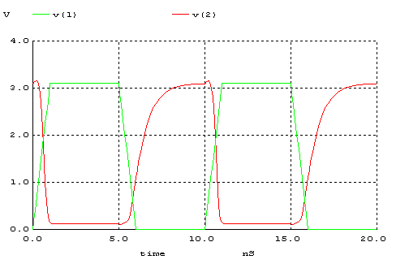

b)

SORU2b
.MODEL MOSN NMOS LEVEL=2 LD=0.15U TOX=200.0E-10
+ NSUB=5.36726E+15 VTO=0.743469 KP=8.00059E-05 GAMMA=0.543
+ PHI=0.6 U0=655.881 UEXP=0.157282 UCRIT=31443.8
+ DELTA=2.39824 VMAX=55260.9 XJ=0.25U LAMBDA=0.0367072
+ NFS=1E+12 NEFF=1.001 NSS=1E+11 TPG=1.0 RSH=70.00
+ CGDO=4.3E-10 CGSO=4.3E-10 CJ=0.0003 MJ=0.6585
+ CJSW=8.0E-10 MJSW=0.2402 PB=0.58
.MODEL MOSP PMOS LEVEL=2 LD=0.15U TOX=200.0E-10
+ NSUB=4.3318E+15 VTO=-0.738861 KP=2.70E-05 GAMMA=0.58
+ PHI=0.6 U0=261.977 UEXP=0.323932 UCRIT=65719.8
+ DELTA=1.79192 VMAX=25694 XJ=0.25U LAMBDA=0.0612279
+ NFS=1E+12 NEFF=1.001 NSS=1E+11 TPG=-1.0 RSH=120.6
+ CGDO=4.3E-10 CGSO=4.3E-10 CJ=0.0005 MJ=0.5052
+ CJSW=1.349E-10 MJSW=0.2417 PB=0.64

M1 2 0 3 3 MOSP W=1.8u L=1.2u NRS=0.333 NRD=0.333
+ AD=6.5p PD=9.0u AS=6.5p PS=9.0u
M2 2 1 0 0 MOSN W=1.8u L=1.2u NRS=0.333 NRD=0.333
+ AD=6.5p PD=9.0u AS=6.5p PS=9.0u

VDD 3 0 DC 3.1
VIN 1 0 PULSE(0 3.1 0 1ns 1ns 4ns 10ns)
C1 2 0 1F
.CONTROL
TRAN 0.1NS 20NS
PLOT V(2) V(1)
.ENDC

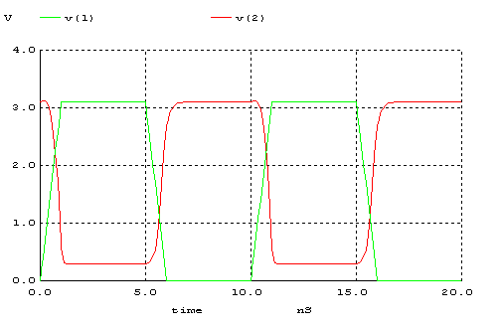

c)

SORU2c
.MODEL MOSN NMOS LEVEL=2 LD=0.15U TOX=200.0E-10
+ NSUB=5.36726E+15 VTO=0.743469 KP=8.00059E-05 GAMMA=0.543
+ PHI=0.6 U0=655.881 UEXP=0.157282 UCRIT=31443.8
+ DELTA=2.39824 VMAX=55260.9 XJ=0.25U LAMBDA=0.0367072
+ NFS=1E+12 NEFF=1.001 NSS=1E+11 TPG=1.0 RSH=70.00
+ CGDO=4.3E-10 CGSO=4.3E-10 CJ=0.0003 MJ=0.6585
+ CJSW=8.0E-10 MJSW=0.2402 PB=0.58
.MODEL MOSP PMOS LEVEL=2 LD=0.15U TOX=200.0E-10
+ NSUB=4.3318E+15 VTO=-0.738861 KP=2.70E-05 GAMMA=0.58
+ PHI=0.6 U0=261.977 UEXP=0.323932 UCRIT=65719.8
+ DELTA=1.79192 VMAX=25694 XJ=0.25U LAMBDA=0.0612279
+ NFS=1E+12 NEFF=1.001 NSS=1E+11 TPG=-1.0 RSH=120.6
+ CGDO=4.3E-10 CGSO=4.3E-10 CJ=0.0005 MJ=0.5052
+ CJSW=1.349E-10 MJSW=0.2417 PB=0.64

M1 2 1 3 3 MOSP W=1.8u L=1.2u NRS=0.333 NRD=0.333
+ AD=6.5p PD=9.0u AS=6.5p PS=9.0u

VDD 3 0 DC 3.1
VIN 1 0 PULSE(0 3.1 0 1ns 1ns 4ns 10ns)
R1 2 0 100K
C1 2 0 1F
.CONTROL
TRAN 0.1NS 20NS
PLOT V(2) V(1)
.ENDC
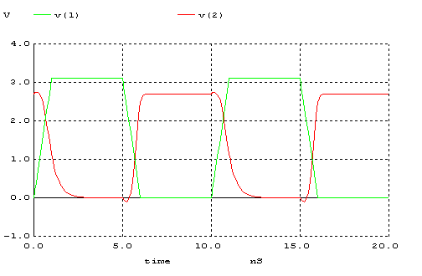

d)

SORU2d
.MODEL MOSN NMOS LEVEL=2 LD=0.15U TOX=200.0E-10
+ NSUB=5.36726E+15 VTO=0.743469 KP=8.00059E-05 GAMMA=0.543
+ PHI=0.6 U0=655.881 UEXP=0.157282 UCRIT=31443.8
+ DELTA=2.39824 VMAX=55260.9 XJ=0.25U LAMBDA=0.0367072
+ NFS=1E+12 NEFF=1.001 NSS=1E+11 TPG=1.0 RSH=70.00
+ CGDO=4.3E-10 CGSO=4.3E-10 CJ=0.0003 MJ=0.6585
+ CJSW=8.0E-10 MJSW=0.2402 PB=0.58
.MODEL MOSP PMOS LEVEL=2 LD=0.15U TOX=200.0E-10
+ NSUB=4.3318E+15 VTO=-0.738861 KP=2.70E-05 GAMMA=0.58
+ PHI=0.6 U0=261.977 UEXP=0.323932 UCRIT=65719.8
+ DELTA=1.79192 VMAX=25694 XJ=0.25U LAMBDA=0.0612279
+ NFS=1E+12 NEFF=1.001 NSS=1E+11 TPG=-1.0 RSH=120.6
+ CGDO=4.3E-10 CGSO=4.3E-10 CJ=0.0005 MJ=0.5052
+ CJSW=1.349E-10 MJSW=0.2417 PB=0.64

M1 2 1 3 3 MOSP W=1.8u L=1.2u NRS=0.333 NRD=0.333
+ AD=6.5p PD=9.0u AS=6.5p PS=9.0u
M2 2 1 0 0 MOSN W=1.8u L=1.2u NRS=0.333 NRD=0.333
+ AD=6.5p PD=9.0u AS=6.5p PS=9.0u

VDD 3 0 DC 3.1
VIN 1 0 PULSE(0 3.1 0 1ns 1ns 4ns 10ns)
C1 2 0 1F
.CONTROL
TRAN 0.1NS 20NS
PLOT V(2) V(1)
.ENDC

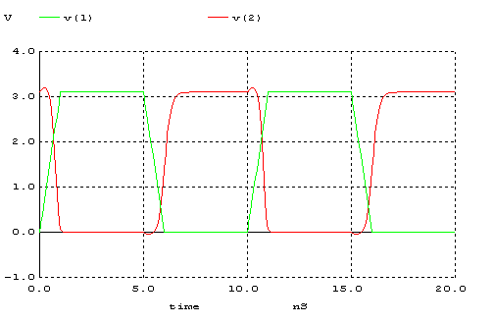

Tablo 2 - Dinamik durum için ölçüm sonuçları
 | tr | tf | t_{pLH} | t_{pHL} | td
(a) | 1,72ns | 300ps | 190ps | 735ps | 462.5ps
(b) | 600ps | 475ps | 345ps | 235ps | 290ps
(c) | 480.5ps | 1.04ps | 403ps | 234ps | 318.5ps
(d) | 600ps | 360ps | 275ps | 550ps | 412.5ps

3)
a)‘d’ devresi tersleyici için en uygun sonuçları vermektedir çünkü en yüksek noise margin değerlerine sahiptir. V_{OH}=V_{DD} ve V_{OL}=Gnd olduğu için ideale yakındır. Ayrıca devre nin girişne uygulanan sinyal Vin=high ve Vin=low durumlarından hangisinde olsun, hiçbir şekilde V_{DD}’den Gnd’ye direk bir hat yoktur. Her durumda sadece 1 transistör ON durumundadır, diğeri cut-off durumundadır. Bu nedenle ‘d’ devresi çok az güç tüketir.
b) Şekilde verilen 4 devreden sadece ‘c’devresi simetriktir.
Diğer devrelerin simetrik olması için ;
a devresinde direnç değeri azaltılmalıdır.
b devresindeki NMOS’un W değeri arttırılmalı veya PMOS’un W değeri azaltılmalıdır.
d devresindeki PMOS’un W değeri arttırlmalı veya NMOS’un W değeri azaltılmalıdır.

4)
SORU1d
.MODEL MOSN NMOS LEVEL=2 LD=0.15U TOX=200.0E-10
+ NSUB=5.36726E+15 VTO=0.743469 KP=8.00059E-05 GAMMA=0.543
+ PHI=0.6 U0=655.881 UEXP=0.157282 UCRIT=31443.8
+ DELTA=2.39824 VMAX=55260.9 XJ=0.25U LAMBDA=0.0367072
+ NFS=1E+12 NEFF=1.001 NSS=1E+11 TPG=1.0 RSH=70.00
+ CGDO=4.3E-10 CGSO=4.3E-10 CJ=0.0003 MJ=0.6585
+ CJSW=8.0E-10 MJSW=0.2402 PB=0.58
.MODEL MOSP PMOS LEVEL=2 LD=0.15U TOX=200.0E-10
+ NSUB=4.3318E+15 VTO=-0.738861 KP=2.70E-05 GAMMA=0.58
+ PHI=0.6 U0=261.977 UEXP=0.323932 UCRIT=65719.8
+ DELTA=1.79192 VMAX=25694 XJ=0.25U LAMBDA=0.0612279
+ NFS=1E+12 NEFF=1.001 NSS=1E+11 TPG=-1.0 RSH=120.6
+ CGDO=4.3E-10 CGSO=4.3E-10 CJ=0.0005 MJ=0.5052
+ CJSW=1.349E-10 MJSW=0.2417 PB=0.64

M1 2 1 3 3 MOSP W=5.4u L=1.2u NRS=0.111 NRD=0.111
+ AD=16.2p PD=11.4u AS=16.2p PS=11.4u
M2 2 1 0 0 MOSN W=1.8u L=1.2u NRS=0.333 NRD=0.333
+ AD=6.5p PD=9.0u AS=6.5p PS=9.0u

VDD 3 0 DC 3.1
VIN 1 0 PULSE(0 5 0 1ns 1ns 5ns 10ns)
C1 2 0 1F
.CONTROL
DC VIN 0 5 0.1
PLOT V(2) VS V(1)
.ENDC

